Final Project Review Report
2022

United Nations Development Programme, Turkmenistan
“Supporting climate resilient livelihoods in agricultural communities in drought-prone areas of Turkmenistan”
Award ID: 00092855
Project Duration: 1/10/2016 – 30/09/2021
Extension(s): 30/03/2022
Implementing Partner: Ministry of Agriculture and Environmental Protection of Turkmenistan
Total Budget: USD 3,146,347
SCCF/GEF Contribution: 3,046,347
UNDP TRAC Fund: USD 100,000
GoT: USD 20,000,000
CO Focal Points: Rovshen Nurmuhamedov, DRR, rovshen.nurmuhamedov@undp.org
Farhat Orunov, Programme Analyst, Farhat.orunov@undp.org
Report Prepared By: Amangul Ovezberdyyeva, Project Manager
Date of Report: February 2022

Brief project description: The “Supporting climate resilient livelihoods in agricultural communities in drought-prone areas of Turkmenistan” project (SCRL project) sought to improve socio-economic conditions of local communities in two pilot regions in Turkmenistan by overcoming barriers that prevent farmers from reducing their vulnerability to climate change induced water stress in the agricultural sector. The SCRL project achieved this objective by implementing targeted activities under three inter-related components, namely (i) improving climate related socio-economic outcomes in targeted agricultural communities in Lebap and Dashoguz velayats through the implementation of community-based adaptation solutions; (ii) mainstreaming climate adaptation measures in agricultural and water sector development strategy and policy; and (iii) strengthening national capacity for iterative climate change adaptation planning, implementation and monitoring in the country.

Through the implementation of the set of inter-related interventions, the project aimed to directly strengthen the adaptive capacity and reduce the vulnerability of around 40,000 to 50,000 persons (of which around 51.2% were expected to be women) in the Lebap and Dashoguz velayats (provinces) by helping them improve the productivity of farm operations, be better prepared for increasing water scarcity and by introducing alternative income sources. Improved water efficiency and crop production systems were expected to bring approximately 20,000 ha of agricultural and 500,000 ha of pastoral lands under climate resilient technologies resulting in a real net household income increase of at least 15% for participating households (including at least 20% of women-headed households). The replication potential of successful efficient water management and climate resilient adaptation practices and of new climate-friendly sectoral planning, legislative and capacity development measures was expected to indirectly benefit around 500,000 people in Turkmenistan, of which around 50% would be women). Overall, project interventions were expected to serve as a stepping stone for the Government’s long-term goal of mainstreaming climate change adaptation at the community, district, provincial and national levels.
Table of Content

ACRONYMS 4
EXECUTIVE SUMMARY 5
I. CONTEXT 7
II. PROJECT RESULTS SUMMARY 9
III. PERFORMANCE REVIEW 17
Progress review 17
(i) Overall progress towards the CPAP outcome and output(s) 17
(ii) Capacity Development 17
(iii) Gender Mainstreaming 17
(iv) Human Rights Mainstreaming 18
(v) Impact on direct and indirect beneficiaries 18
(vi) Communication and publicity 18
Implementation strategy review 19
(i) Sustainability 19
(ii) Participatory/consultative processes 19
(iii) Quality of partnerships 19
(iv) National Ownership 20
Management effectiveness review 20
(i) Monitoring and Evaluation 20
(ii) Timely delivery of outputs 21
(iii) Resource Allocation 21
(iv) Cost-effective use of inputs 21
IV. IMPLEMENTATION ISSUES 22
V. LESSONS LEARNED 24
VI. FINANCIAL STATUS AND UTILISATION 30
Financial Summary 30
Financial Overview 30
Financial Utilization 31
ANNEXES 33
Annual Work Plan 33
Project Document 33
Charts, tables and visual aids, with accompanying analytical descriptions (1-2 paragraphs per table/chart). 33

Table 1: Issues Log 22
Table 2: Lessons Learned 24
Table 3: Financial overview for the whole duration of the project 31
Table 4: Financial utilization by donor and activity for [ex. 2009] 32

ACRONYMS

AWP | Annual Work Plan
CCA | Climate change adaptation
CPAP | Country Programme Action Plan
GEF | Global Environment Facility
ICTA | International Chief Technical Adviser
IWRM | Integrated water resource management
LPC | Local Project Coordinator
LAP | Local Adaptation Plan
MAEP | Ministry of Agriculture and Environmental Protection
MRV | Measuring, reporting and verification
SCWM | State Committee on Water Management
NDC | Nationally determined contribution to Paris Agreement
NC | National Consultant
NCCM | National Consultant on community mobilization
NCCS | National Climate Change Strategy
PA | Programme Assistant
PIU | Project Implementation Unit
PM | Project Manager
PS | Project Specialist
PVAA | Participatory vulnerability and adaptation assessment
RTA | Regional Technical Advisor
SCCF | Special Climate Change Fund
SCRL | Supporting climate resilient livelihoods in agricultural communities in drought-prone areas of Turkmenistan project
SDG | Sustainable Development Goals
SCWM | State committee on water management
UNDP CO | United Nations Development Programme Country Office
UN PFD | United Nations Partnership Framework for Development

EXECUTIVE SUMMARY
This project was relevant to Turkmenistan’s national climate adaptation needs and priorities, and the climate adaptation needs and priorities of the local communities in the two pilot regions of the project in Gorogly etrap of Dashoguz velayat and Danew etrap of Lebap velayat. The project results and progress achieved toward the expected outcomes were positive.
The key project results include:
- Based on the Participatory Vulnerability and Adaptation assessment, Local gender-sensitive adaptation plans for six farmers associations and two livestock farms elaborated and fully implemented;
- 29 small grant initiatives carried out to support implementation of the Local gender-sensitive adaptation plans;
- Completion of multiple field-level adaptation measures/water infrastructure improvement projects in the two pilot regions aimed to increase crop productivity and alternative source of income;
- The revision of the Turkmenistan National Climate Change Strategy (adopted in September 2019);
- The support provided to the revision process of the Nationally Determined Contributions on Paris Agreement and Road Map and recommendations on designing the MRV system on climate change adaptation measures as part of Enhanced Transparency Framework;
- 20 Agro-ecological zones identified for two pilot regions as tool for climate change adaptation planning process;
- The adoption of the Turkmenistan Law on Land Cadastre (November 2018), to which the project contributed significantly, is one of the key successes of this project.
- The support provided to the preparation of the new version of the Turkmenistan Land Code, amendments to the Laws on Daikhan (farmers’) Associations and Daikhan (farmers’) Unions and other legal documents on water and land use issues;
- Multiple expert policy recommendation documents (guidelines, concept note, recommendations on the Agricultural Extension Services, mainstreaming climate change adaptation, gender considerations, ecosystem-based adaptation etc.) provided to the Government for considering as part of reforming agriculture and water management sectors;
- Integrated water resources management (IWRM) and Climate Box have been presented for introduction to the curricula of educational institutions of the country;
- Series of trainings conducted during lifespan of the project enabled to strengthen capacities of local population in pilot communities to efficient use of water and land resources and their resilience to adverse effects of climate change.
- About 35 different informative materials including booklets, leaflets, brochures related to climate change adaptation measures and best practices in this field were printed in three languages – Turkmen, Russian and English and distributed to beneficiaries in the communities, to educational institutions, to government agencies.
Since 2020 the project has experienced certain delays related to COVID-19 pandemic, including implementation of small grant activities, formal adoption of legal documents, organization of awareness raising events, international and in-country travels and other factors. Therefore, the project has been extended for 6 months until 31 March 2022. Despite impacts of the COVID-19 pandemic, which considerably slowed down the project implementation, the project has made further progress towards achieving targets set for all key indicators.
This report is organized in a logical way of describing summary of project results by components of the project, review of achieved progress and used implementation strategy, as well as monitoring and evaluation activities implemented for efficient management of the project. The report is also supplemented with Lessons Learnt Report and financial overview and utilization charts.

CONTEXT
The objective of the SCRL project was to support climate resilient livelihoods in agricultural communities in the Lebap and Dashoguz velayats in Turkmenistan. The project’s incremental value focused on enabling farmers in the driest regions of the country to overcome the critical barriers that prevent them from reducing their vulnerability to climate change induced water stress and other environmental hazards in the agricultural sector.
The project assessed and delivered a matrix of concrete climate adaptation solutions to local vulnerable communities in two agro-ecological regions, while also strengthening national water and land legislation, and building capacity to ensure water availability for the non-state sector farmers. This combination of outcomes ensured that concrete actions implemented through SCCF resources would be sustainable beyond the lifetime of the project.
The results of SCRL project have been pursued in line with the National Socio-Economic Development Programme until 2030. The SCRL project’s interventions were also aligned with other national priorities and frameworks, including the National Climate Change Strategy (adopted in 2012, revised in 2019).
Project resources have been applied towards achievement of the Country Programme Action Plan (CPAP) Outcome 2 (UNPFD/CPD outcome #6) “The national policy, legislative and institutional frameworks are responsive to climate change issues by promoting climate resilience, adaptation, climate risk management and disaster risk reduction measures at sector and community levels”. The project was aligned with the UNDP CO Strategic Plan: Goal 4: Managing Energy and the environment for sustainable development; Outcome 3: “Strengthened capacity of developing countries to mainstream climate change adaptation policies into national development plans”. The project also contributed towards achieving the realization of the Sustainable Development Cooperation Framework between the Government of Turkmenistan and United Nations 2021-2025, Outcome 3 “By 2025, there is effective design and implementation of disaster risk reduction, climate adaptation and mitigation measures enabling a more rational use of resources, increased resilience, and a ‘green’ economy transition”.
With regards to the SDGs, the SCRL project was aligned with SDG 13 “Take urgent action to combat climate change and its impacts”, having contributed to the following related targets:
- Target 13.1: Strengthen resilience and adaptive capacity to climate-related disasters.
- Target 13.2: Integrate climate change measures into policy and planning.
The SCRL project, through its three outcomes, was designed to also directly contribute to the GEF strategic objectives under the Climate Change Adaptation Focal Area: CCA-1 - Reduce the vulnerability of people, livelihoods, physical assets and natural systems to the adverse effects of climate change; CCA-2 - Strengthen institutional and technical capacities for effective climate change adaptation; and CCA-3 - Integrate climate change adaptation into relevant policies, plans and associated processes.

The project was implemented under the National Implementation Modality (CO support to NIM), with the Ministry of Agriculture and Enironmental Protection (MAEP) serving as the national executing agency (National Implementing Partner, IP) overseeing all aspects of project implementation. Given the SCRL project’s wide scope of activities, it engaged a wide range of partners - government staff, local specialists of farmer associations, farmers, scientists and students, women, etc. The Project Management Board (PMB) consisted of representatives of the MAEP, the Parliament of Turkmenistan, the State Service on Hydrometeorology under MAEP, the Ministry of Finance and Economy, Daikhanbank, Hakimliks of Lebap and Dashoguz velayats, Hakimliks of the etrap of Gorogli of Dashoguz velayat, Hakimlink of etrap of Danew (former Galkinish) of Lebap velayat, the State Committee on Water Management and its State Institute of Water Management Design (SIWMD), the Union of Industrialist and Entrepreneurs (UIE); and UNDP.

The project was structured such that most its activities were implemented at the community level to deliver concrete adaptation benefits to identified agricultural communities located in two provinces – Lebap velayat and Dashoguz velayat. Key players in the project were the selected six pilot Daikhan (Farmer) Associations and two Livestock Associations.The project worked directly with the selected associations and their agricultural communities, helping farmers overcome barriers by enhancing water and land management techniques, ensuring capacity development and knowledge sharing. Key project stakeholders at the subnational level also were the representatives of velayat and etrap authorities, having provided oversight and support to the vulnerability assessment and planning, as well as implementation and monitoring of the participatory Local Adaptation Plans (LAPs) developed in cooperation with the farmer and livestock associations. Apart from being direct beneficiaries, Daikhan Associations and Livestock Associations also participated in decision making at all stages on all activities related to agriculture, irrigation, drainage, and sustainable land and pasture management in the pilot etraps.

In order to support the scaling up of community-level adaptation solutions, at the national level, in close collaboration with national partners, the project supported the drafting of a series of legislative modifications, particularly to the land and water codes, and subsidiary legislation and regulations. These changes were supplemented by a dedicated Capacity Building and Training program, and the elaboration and publication of a set of guidelines and manuals. Accordingly, the project ultimately contributed to national-level policy development, the reduction of the country’s vulnerability to climate change and the building of resilience as its long term (development) objectives.

PROJECT RESULTS SUMMARY
Overall, over the course of its lifetime, the SCRL project has for the most part achieved all the targets that were identified in the project’s results framework at the project design stage. The following are the key achievements of the project by component:
Outcome 1: Improved climate related socio-economic outcomes in the targeted agricultural communities in Lebap and Dashoguz velayats through the implementation of community-based adaptation solutions.

Under outcome 1, the SCRL project achieved the more resilient management of agricultural land, through the formulation and implementation of LAPs, including small grant allocations provided to the agricultural communities of the 6 farmers’ associations and two livestock farms. The SCRL project also organized various trainings and agro-consultations (on-site and remote) that raised the awareness and skills of farmers and the local population on alternative sources of income, irrigation technologies, and sustainable water and land use practices in both pilot regions.

Adaptation measures implemented by the SCRL project contributed to improved soil physical conditions and a more efficient use of water and fertilizers, which improved crop productivity of farm lands and household plots. Under outcome 1, the project’s overall achievements are assessed as satisfactory. Specific key achievements under outcome 1 include:
- Local Adaptation Plans were designed and adopted in cooperation with agricultural communities of the six farmers’ associations and two livestock farms. The successful implementation of the LAPs was supported through grant means provided by the project as well as own means, with targeted assistance provided by the local project team, including through trainings and consultation workshops.
- Innovative climate resilient technologies and practices on improved soil and water management practices were demonstrated in both pilot regions towards improving crop production and livelihoods. Examples include laser land levelling, the installation of water intake pumps, promoting water saving technologies (drip irrigation system, siphons, hosepipes), the application of bio-humus, cultivation of the soybean, installation of irrigation water regulating structures and measuring units, etc.
Figure 1: Laser Land Leveling | Figure 2: Installation of Water Intake Pumps
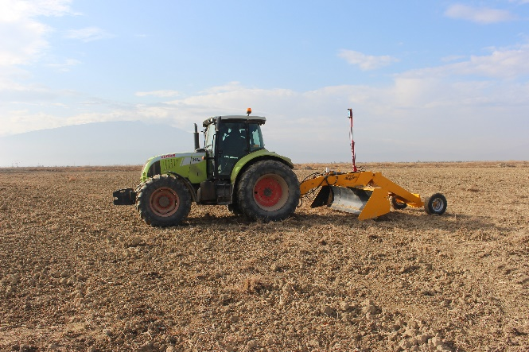 | 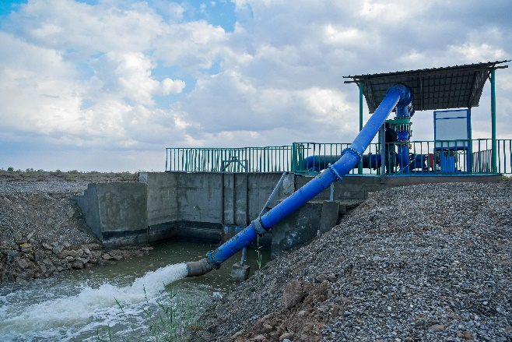

- Agricultural Information Centers (AICs) were established in the two pilot regions and have served as platforms for sharing knowledge and experience with regards to aspects of climate change adaptation and effective agriculture management. AICs were instrumental in building capacities designed to create a critical mass of efficient climate-smart agricultural practitioners. Trainings were a key component of this program, and in particular with an emphasis on learning by doing. The AICs also specifically supported project investments, through the provision of on-site and remote agro-consulting services by project specialists and external consultants, supported by targeted awareness campaigns organized by the SCRL project.

Figure 3: AIC in Danew etrap | Figure 4: AIC in Gorogly etrap
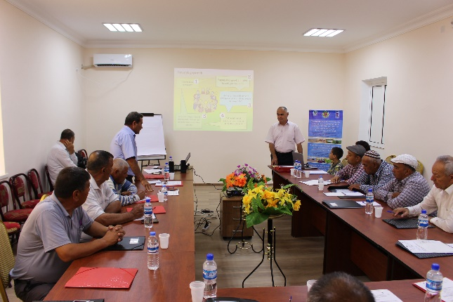 | 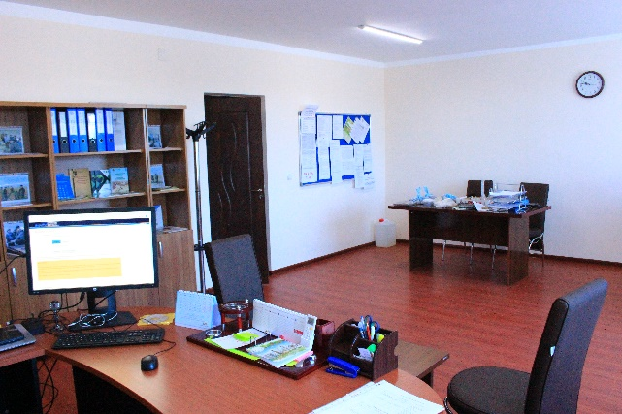

- Community-based Adaptation Initiatives organized by the SCRL project strengthened the adaptive capacities of target communities through the allocation of small grants and the provision of agro-consultations (remote and on-site). During two rounds, launched in 2019 and 2020 respectively, a total of 29 grant initiatives were funded. The grant initiatives were crucial in demonstrating the usefulness and feasibility of various approaches and adaptation technologies on improved soil and water management practices in support of improving crop production and livelihoods to recipient farmers and the broader communities of the pilot regions. The full list of grant initiatives is presented in Annex 3 of this report.
- Alternative livelihood and income-generating opportunities were introduced by the SCRL project to selected households in the pilot farmers’ associations and livestock farms. Examples include the (re-)construction of greenhouses (three in Lebap and two in Dashoguz), the production of honey, the opening of a sewing club, mushroom cultivation, horticulture development, etc. As result, the project was instrumental in directly and indirectly increasing the income of the participating households, as well as of the wider local population, including representatives of private sector (entrepreneurs) providing different agricultural services and inputs.

Figure 5: Re-construction of the sardoba and kak in remote area of Garagum livestock farm | Figure 6: Re-construction of greenhouse in Babadayhan f/a
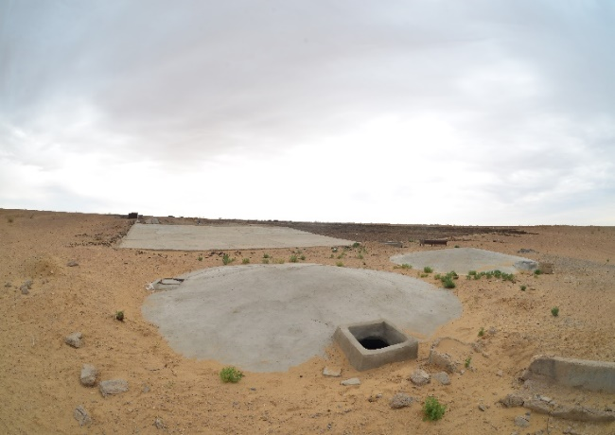 | 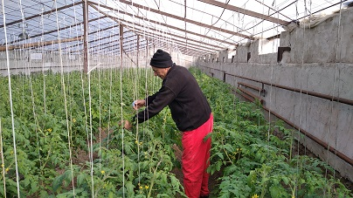
Figure 7: Construction of water regulation units in Yagtylyk f/a | Figure 8: Composting of organic waste in Zaman f/a
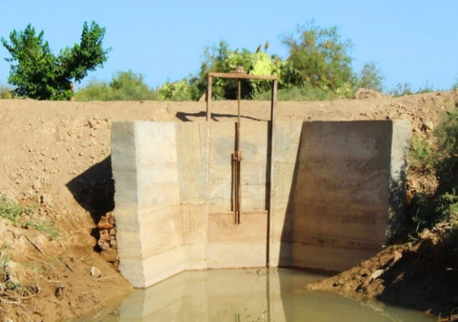 | 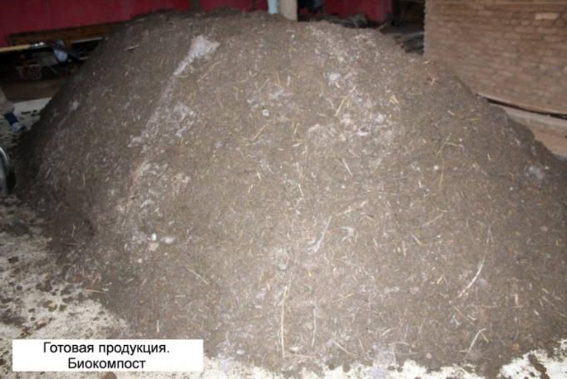
Figure 9: Sewing club in farmers association named after B. Ovezov | Figure 10: Cleaning of irrigation canal in Watan f/a
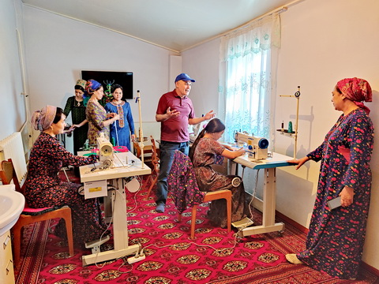 | 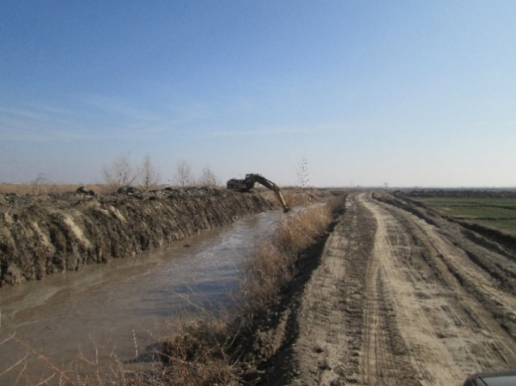
Figure 11: Application of No-till technology in Parahat f/a | Figure 12: Application of the multifunctional vegetable sowing equipment in Abadanlyk f/a
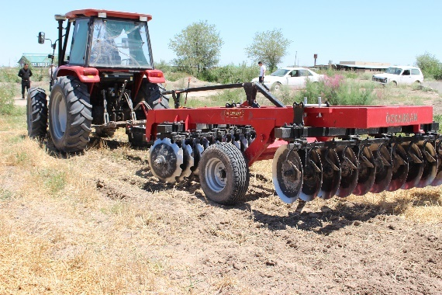 | 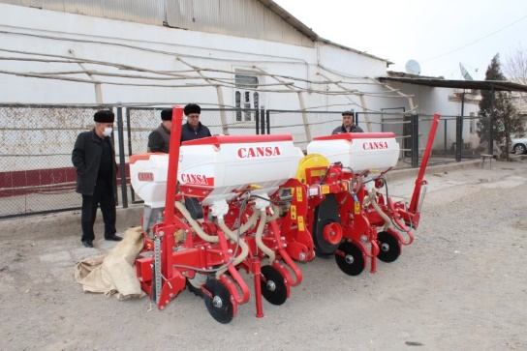

- Campaign on planting high-value fruit trees, coinciding with nationwide events dedicated to the planting of trees. Aimed at strengthening the climate resilience of the rural population by promoting horticulture development as an alternative source of income. During the campaign about 5,000 fruit tree seedlings were planted by UNDP and national partners, supported by the USAID project on Competitiveness, Trade and Job Creation in Central Asia (CTJ). The tree planting campaign was preceded by a series of training sessions on horticulture development. More than 50 representatives of the private sector, local communities, universities and local administrations, of which 50% were women, participated in the campaign.
- Activities on sustainable pasture management were implemented jointly with the Central Asia Nexus Dialogue project and local pastoral communities. Key practical achievements, including (i) reduced land degradation through improved pasture rotation; (ii) increased livestock farm productivity (increased number of cattle sustainably grazed); (iii) use of sustainable solar energy for water pumps in remote locations; (iv) rationed use of water resources in an arid desert environment; and (v) overall reduced pressures near cattle watering places, promoting desert vegetation restoration.

Figure 13: Solar Panel Installation on Esenaman remote area
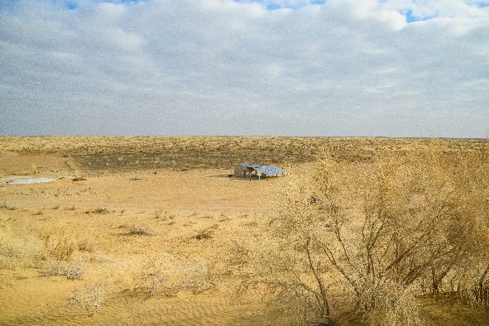 | 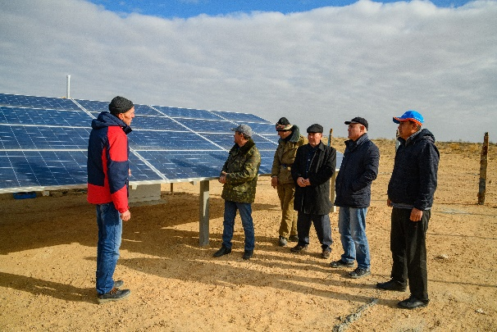

- Information and knowledge materials were prepared and published, presenting a broad variety of information on SCRL project results and achievements, recommendations and lessons learned. These included project flyers, a brochure on project activities, a booklet on project approaches, information leaflets and many more. Also different informative materials were produced, including booklets on the project activities, Climate Box publications, manual on bio-humus production, practical advice on horticultural practices, brochure on mushroom cultivation, leaflets on innovative water saving technologies, as well as various thematic posters and administrative maps of farmers associations.
Overall, the SCRL project has been instrumental in directly and indirectly increasing the incomes of participating households, as well as of the local communities, including representatives of private sector (entrepreneurs) providing different agricultural services and inputs. Adaptation measures promoted by the project in the eight target communities have benefitted local farmers through improved irrigation technologies, sustainable water and land use practices, and better crop production. As result
- 21,964 ha of agricultural lands and 500,116 ha of natural pasture lands are used under sustainable management approaches;
- 40,018 people (51% of whom are women) directly benefited from climate change adaptation measures;
- 3,026 targeted farmers/households of which at least 30% are women/women-headed households reported improved crop production systems and livelihoods; and
- 52% of participating households from 6 farmers’ associations and 2 livestock farms reported 10-15% additional income earned from alternative climate-resilient livelihood activities, of which 20% are female-headed households.

Outcome 2: Mainstreamed climate adaptation measures in agricultural and water sector development strategy and policy
Under Outcome 2 the project contributed to enhancing the knowledge and capacities of farmers, specialists and decision makers on climate change risk reduction measures in agriculture and improved soil and water management approaches, as well as to strengthening institutional capacities and the regulatory framework. The project’s overall achievements under this Outcome 2 are assessed as moderately satisfactory. Specific key achievements under outcome 2 include:
- Policy and Legal Documents – The SCRL project initiated or contributed to the development of in total 25 policy documents and legal instruments, the full list of which is presented in Annex 4. Examples of key policy and legal documents include:
- Policy documents:
  - Updated 2019 version of Turkmenistan’s National Climate Change Strategy, and revision of Turkmenistan’s Nationally Determined Contributions (NDC-2) to the Paris Agreement in the area of climate change adaptation
  - Concept paper for the development of the National Agricultural Extension System in Turkmenistan
  - Recommendations for the designing of a MRV system
  - Instruction on the collection, processing and storage of gender-disaggregated data, and Conceptual methodological guidelines on the use of gender-disaggregated data in sectoral adaptation planning and budgeting for water and agriculture ministries
  - Concept paper on modelling Agro-ecological zones and its practical application, with relevant support materials, including GIS repository
- Legal documents:
  - Two sub-laws related to the Land Cadaster (October 2018; November 2021
  - A package of Amendments to the Law on Farmers’ associations and the Law on Farmers Unions
  - Concept for the draft law on the Creation of Agricultural extension services in Turkmenistan

- Capacity building– The SCRL has organized an impressive number of 150 training events (seminars, round tables, workshops, lectures, etc.) aimed at strengthening the capacity of farmers, agriculture specialists and decision makers at the national and sub-national levels. Key topics of the events included the strengthening of farming techniques and skills of farmers, methods for the rational use of water resources, the development of legal instruments and regulations, the development of adaptation plans, including data collection and analysis, and the gender dimension of adaptation planning and implementation. In total, 3,018 farmers/community members, of which 26% are females, and 567 government staff, of which 27% are females were engaged in the training. In addition, about 390 farmers received project support on on-farm soil and water management practices.
Capacity building and training events were facilitated by national staff, national and/or international consultants engaged either by the SCRL project or by its partners, including partner UNDP projects, or projects by FAO orUSAID. Trainings have been facilitated by the local Agro-Information Centres (AICs) established by the project. In response to COVID-19 challenges, most of the training events in 2020-2022 were conducted on-line as virtual meetings.
- Consultations - The project developed and implemented a targeted approach to provide on-site and remote agro-consultations that raised the awareness and skills of farmers and the local population on alternative sources of income, irrigation technologies, and sustainable water and land use practices in both pilot regions. Topics of the agro-consulting services included weather forecasting, soil and water analyses, irrigation schemes, land laser levelling, application of fertilizer, composting and crop-specific farming techniques. Agro-consultiations were carried out mainly on the basis of the AICs located in the Dashoguz and Lebap regions as well as by means of an established communication platform. The AICs in the two pilot regions provided free consultations to the local communities on topics, such as: legislation, agro-business development, alternative source of income, education, capacity building (computer skills, internet resources etc.), employment opportunities, innovation technologies, supplies in the field of agro-industry, etc.
Figure 14: Field Day on soil assessment for land-users (tenants) | Figure 15: On-site consultations on application of bio-humus at household level
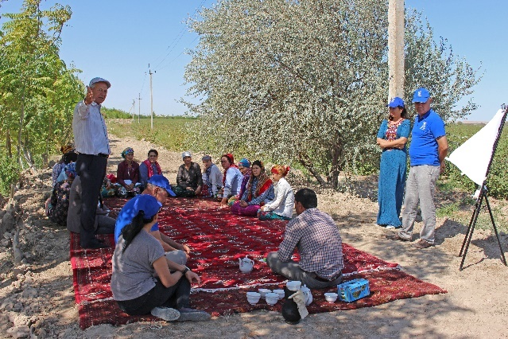 | 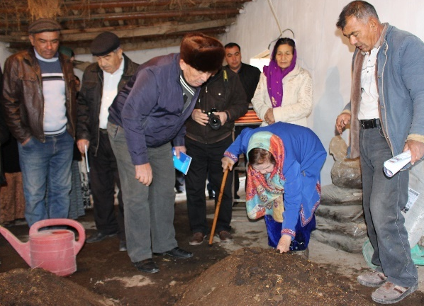

- Awareness-raising Events and Information Materials - The SCRL project numerous awareness-raising events on a large variety of adaptation topics. Many awareness-raising activities were organized in close cooperation with international project partners such as the FAO/CACILM project, the Russian on Demand program, the UNDP Global Support Program, the USAID-funded projects GSP and CTJ projects, and the UNDP “Sustainable cities” project. The project also published a multitude of information materials such as press-releases, leaflets, booklets and guidelines disseminated among farmers, government officials, target communities and students of different educational institutions. Also the project promoted the relevance of Integrated Water Resources Management (IWRM), as a result of which a new discipline "Integrated Water Resources Management" was introduced into the curriculum of the Turkmen State Agricultural Institute.

- Mainstreaming climate change adaptation - The project developed Guidelines for mainstreaming climate change adaptation into sectoral plans for agriculture and water sectors. The main principles of the Guidelines, as well a summary of the SCRL project’s experience of applying these principles during the preparation of LAPs were presented at a workshop held on 23 April 2021. In October 2021, the Guidelines were submitted to the Ministry of Agriculture and Environment Protection for consideration and use in the course of national sectoral adaptation planning.

- Concept Note on establishing Agricultural Extension Services (AES) - The SCRL project formulated the Concept Note on establishing AES in Turkmenistan, aimed at the development of a functioning institutional system of agricultural extension services, including remote counselling tools, to support an increasing number of private farmers, rural and household farming businesses. The Concept Note was presented in detail to a wide stakeholder audience on June 18, 2021, along with the concept Law on Agro-Consulting Services in Turkmenistan, a complimentary document that aims to support the AES development process in the country. The importance and relevance of the development of AES was outlined in the National Socio-Economic Development Plan of Turkmenistan until 2030.

Outcome 3: Strengthened national capacity for iterative climate change adaptation planning, implementation and monitoring

Under outcome 3, the SCRL project supported the Government of Turkmenistan in policy development for planning climate change adaptation, taking into account the recent national reforms, acceptance of SDGs and Paris Agreement as well as recent climate change observations. For Outcome 3 the project’s overall achievements are assessed as moderately satisfactory. Specific key achievements under outcome 3 include:

- Road Map on designing a Measurement, Reporting and Verification (MRV) system for climate change adaptation - The SCRL project supported by national and international partners, including the USAID Global Support Program and the UNDP Sustainable cities project, developed the Roadmap on MRV for adaptation, which was presented at the national workshop held in August 2021. Subsequently the MRV Road Map was submitted to the government of Turkmenistan for adoption and incorporation into the policies of the in agriculture and water sectors will further promote adaptation planning processes towards ensuring meeting the country’s commitments under the Paris Agreement with regards to the enhanced framework transparency.
- Revision of the Nationally Determined Contribution (NDC) – the SCRL project provided guidance and support to the preparation of the revised NDC report in the area of climate change adaptation, being part of Turkmenistan’s commitments for the implementation of the Paris Agreement. The updated NDC report was submitted to the Government of Turkmenistan and circulated among key ministries and organizations with designated responsibilities. The revised NDC report was also discussed during an online Development Partners Climate Group Coordination meeting on October 19, 2021, organized by the UNDP CO together with the British Embassy in Turkmenistan, aimed at continuing the established dialogue with the Government of Turkmenistan on the implementation of development projects in the field of environment and climate change. The formal approval of the NDC is under discussion by Government of the country.
- Conceptual methodological guidelines on the use of gender-disaggregated data in adaptation planning and budgeting for the water and agricultural sectors -
- Multilevel cluster maps (MLCMs) and a GIS system were developed, combining agrophysical data (soil, water, topography, terrain, crops, infrastructure, vegetation, etc.) with up-to-date information on current and forecasted climate conditions. A special webinar was organized to acquaint stakeholders with the use of MLCM. The SCRL project negotiated with the Scientific-Information Center (SIC) of the Interstate Sustainable Development Commission of the International Fund for Saving the Aral Sea to hand over the project products for further use in scientific and practical work of the SIC in cooperation with the National Institute of Desert, Flora and Fauna. Also, the State Agriculture Institute has informed the project that the MLCMs will be used as an educational toolkit for students.
- Modelling of Agro-ecological zones (AEZs) – The SCRL project strengthened knowledge and capacities for the development of the AEZ modelling approach for the optimal placement of crops in the two pilot velayats. A number of working meetings and workshops were conducted to introduce and discuss the AEZ approach with national partners and interested parties, and to promote this tool for national/provincial planning. To strengthen awareness and understanding on AEZ modelling, the project engaged international expertise for the development of a Concept Paper on modelling Agro-ecological zones and its practical application.

Overall, despite restrictive measures taken in response to the COVID-19 pandemic, globally and in Turkmenistan, the project has for the most part achieved all the targets that were identified in the project’s results framework for all 3 outcomes. The SCRL project has been instrumental in directly and indirectly increasing the incomes of participating households, as well as of the local communities, including representatives of private sector (entrepreneurs) providing different agricultural services and inputs. Adaptation measures promoted by the project in the eight targeted communities have benefitted local farmers through improved irrigation technologies, sustainable water and land use practices, and better crop production. The SCRL project was successful in promoting legislative and regulatory changes, which is an important factor for sustainability as these changes are engrained in the country’s regulatory and policy framework. Also, the project’s extensive work on training and awareness raising is another important factor of sustainability.

PERFORMANCE REVIEW

Progress review
- Overall progress towards the CPAP outcome and output(s)
The project contributed to achieving Outcome #6 of the UNDP CPAP for Turkmenistan: “the national policy, legislative and institutional frameworks are responsive to climate change issues by promoting climate resilience, adaptation, climate risk management and disaster risk reduction measures at sector and community levels”. Specifically, the project contributed to the following CPAP Outputs:
- Output 6.1: New and innovative solutions developed and piloted at national and subnational levels for climate change adaptation, sustainable land, water, coastal management and ecosystem services, and safe waste disposal as part of NEPAAM;
- Output 6.2: Institutional capacities are strengthened at subnational level in adaptation/CRM planning and implementation, to promote stronger local livelihoods through sustainable use of water, land, biodiversity and coastal areas.

- Capacity Development
The SCRL project has strengthened the capacity for efficient and effective water and land management in Turkmenistan at both the personal and institutional level, among farmers and specialists, local communities as well as etrap-, velayat- and national-level decision makers. At the national level, the project supported systemic capacity development, through strengthening agriculture, land and water management policies and regulations. At the community level, the project conducted a variety of awareness raising events in the two pilot regions, which strengthened the target audiences’ knowledge on innovative, climate resilient agriculture technologies, climate change risk reduction measures in irrigated agriculture and improved soil and water management approaches, using theoretical and hands-on trainings, workshops, information and field days, webinars and working meetings, remote and on-site agricultural consultations, small grant initiatives etc. In addition, a dedicated series of training events contributed to increasing the motivation of land and water users to participate in decision making processes, resulting on 8 Local Adaptation Plans developed and adopted for 8 pilot farmers’ associations and 2 livestock farms.
- Gender Mainstreaming

The SCRL project has had a significant focus on the gender dimension. The project placed women in the project target area at the center of the project by clearly recognizing that the needs and priorities, as well as the specific challenges women meet in their daily life, are exacerbated by the effects of climate change. Facilitating gender mainstreaming was incorporated in all project activities and results, ensuring that women and men had equal opportunity to be heard, participated in, and benefitted from project activities. Special attention was paid to ensure the participation of female-headed households and vulnerable groups in project activities, Gender empowerment training was conducted for local authorities to strengthen the engagement of women in decision making processes. Gender responsive community-based LAPs were drafted with the active involvement of women, including subsequently in their implementation. Also, the small grant programme included specific criteria to encourage applications to be submitted by women-headed households, as a way to provide livelihoods support to poor and vulnerable women. The project supported the developed of an instruction for the collection and storage of gender-disaggregated data, as well as a guideline on the use of sex-disaggregated data towards strengthening women's needs in state sectoral planning and budgeting in water and agricultural sectors. Overall, women represented 50% of project beneficiaries.
- Human Rights Mainstreaming
Overall, the SCRL project followed a human rights approach by targeting the most vulnerable groups and regions, as well as addressing the rights of women, people with disabilities, etc. Throughout its implementation period, the project has worked with agricultural communities of eight farmers associations in two pilot regions in Turkmenistan, focusing its activities on strengthening the adaptive capacity and reducing the vulnerability of beneficiaries to climate change impact, as such contributing to the basic right to a safe and ecologically-balanced environment. Also, the project used transparent participatory processes in development planning, supporting local governments to be more open, transparent and accountable to the public. Through its support to water infrastructure and agricultural development initiatives, the project contributed to job creation, reducing the need for people to seek jobs outside their communities, as such also reducing poverty and vulnerabilities, all crucial aspects of human rights.

- Impact on direct and indirect beneficiaries
The SCRL project has contributed across of range of areas and through a variety of activities to the promotion of innovative measures for sustainable land and water management, as well as sustainable pasture management. The project’s stakeholders, including beneficiaries in the Dashoguz and Lebap velayats, highly valued these activities. Through trainings and awareness raising activities, remote and on-site agricultural consultations, the demonstration and implementation of practical adaptation measures as well as the allocation of grants, the project activities in the eight targeted communities across the two pilot regions have benefitted local farmers as well as regional and national decision makers. The project estimates that the total number of people population benefitting from the implementation of this project amounts to about 40,000 direct beneficiaries of which 51% were women.
- Communication and publicity
The project team had ensured good communications with internal stakeholders and external audiences, using various channels.
The project also published a large amount of information and knowledge materials (flyers, brochures, booklets, thematic posters, information leaflets, etc.), which presented a variety of information, including the results of the project, achievements, recommendations and lessons learned. Information, including press releases, on workshops and training activities of the project were regularly published at the UNDP Turkmenistan website, social network (IMO, Instagram), websites of national and regional media services, and different newspapers and magazines. A success story on the implementation of adaptation measures in the Danew pilot region was featured during the GCA-led Adaptation Week (November 30-December 4, 2021) and UNDP’s Climate Exposure channel.
In total, about 35 booklets and brochures related to adaptation measures and best practices were produced and printed in three languages – Turkmen, Russian and English. The publications were distributed among beneficiaries in the pilot communities, among educational institutions and government agencies. Knowledge products and lessons learned were also presented to, and discussed during, project board meetings, and shared with beneficiary communities and stakeholders as well as government partners. Also, the project has regularly participated in national initiatives and events, such as the Environment Protection Day and the Agricultural Exhibition-Fair, during which information on project results was widely disseminated.

Implementation strategy review
- Sustainability
In order to achieve sustainability, the SCRL project adopted a highly participatory approach to engage a large number of stakeholders, including stakeholders at the sub-national level as well as the environmental community in the country. Wide consultations conducted in the course of the project have increased awareness on climate change adaptation both within all levels of the government as well as in the pilot communities and wider national society, which is a positive factor for social sustainability. Specifically, the SCRL project was successful in promoting legislative and regulatory changes, changes that remain engrained in the country’s regulatory and policy framework. Also the project supported the establishment and strengthening of a range of institutional structures – AICs, LAPs, Road Map on MRV for adaptation, etc., as well as the publication and dissemination of different informative materials produced by the project. As such, the project has ensured good ownership by all relevant socio-economic groups and local communities, which lowers socio-economic risks as an important factor for achieving sustainability.
- Participatory/consultative processes
Since the start of the project, the participatory approach adopted by the SCRL project has facilitated the involvement and participation of households of farmer and livestock associations, including the vulnerable and marginalized members of the community (including women) in the planning and implementation of the project activities. Assessments of vulnerability and capacities have been instrumental in identifying the most appropriate targeted project activities, including training and awareness raising initiatives, field demonstrations, remote and on-site agro-consultations on current and innovative farming practices, and grants designated for the practical implementation of climate change adaptation practices. Monitoring by project staff in the pilot regions provided evidence that target groups were being reached as intended.
- Quality of partnerships
The SCRL project has been exemplary in liaising with several national and international institutions, civil society organizations (CSOs), the private sector, as well as technical support projects and initiatives to exchange knowledge and experiences, share lessons learned and information , as well as to cooperate in a practical manner on aspects of climate change adaptation towards sustainable land and water management, on improving land and water legislation, and on the revision and updating of the NDC.
Specifically, the project established collaboration agreements with the UNDP/UNEP Global Support Program, the Russian Experts on Demand Programme, the FAO CACILM project, the USAID-funded projects “Competitiveness, Trade, and Jobs Activity in Central Asia” and “Governance Support Program”, as a result of which additional resources could be mobilized and project activities could be better coordinated. With government structures, specifically the MAEP and its subordinated structures and regional departments, the State Water Committee, the Parliament, the Ministry of Economy and Finance, the Hydro-meteorological service, the hyakimliks of 2 velayats and 2 etraps, the National Institute for Desert, Flora and Fauna, Turkmensuwylymtaslama, Dayhanbank, the Turkmen State Agriculture Institute and the UIE, the project interacted actively and effectively towards strengthening institutional capacity for climate change adaptation and mainstreaming adaptation into sectoral planning. With several Civil Society Organizations such as Tebigy Kuwwat, Youth Center Bosphor, Turkmenistan Support Center for Disabled People, Turkmen Nature Protection Societies etc., collaborations focused on awareness raising on climate change adaptation, the provision of legal and agro-consultations, as well on revision of the NDC-2.
The joint activities implemented to date enabled a strengthening of climate resilient livelihoods, through (i) capacity building through the organization of joint events, and consultation and trainings provided by national and international consultants on alternative sources of income, (ii) the procurement of a smart greenhouse in the Dashoguz region, (ii) the procurement of bio-humus for local farmers producing soybean; (iii) the procurement of seedlings for local beneficiaries in both pilot regions; and (iv) the publication of several information materials (on horticulture, mushroom cultivation, bio-humus production).
- National Ownership
From the design stage as well as during implementation of the SCRL project, planning and decision making on project goals and targets as well as relevant activities was conducted with the full engagement of all relevant key stakeholders, including national partners (the MAEP, the State Committee on Water Resources, Parliament, the Ministry of Finance and Economy, and others), as well as regional stakeholders (farmers associations, provincial and district authorities). Other relevant and interested institutions were engaged into targeted project activities, as appropriate.
Throughout its implementation period, the project maintained regular monitoring of the institutional structure and systems in place in Turkmenistan, their capacities and performance. In response to political reforms, due to which the main implementing project partner has been changed twice, the project successfully applied adaptive management to minimize delays and upheaval, supported by a National Project Coordinator (NPC) who fortunately was not changed during the lifespan of the project, and maintained the ability to support the planning and implementation of project activities at national and local levels.
The Project has prepared sustainability plans of action at the national, provincial and local levels, which specifically in the last year of project implementation have been revised and agreed on a regular basis. Aspects of transition and hand-over were elaborated, specifically for ensuring the continued operationality of the AICs.

Management effectiveness review
The SCRL project has delivered most of its expected outputs, as evidenced by the approximations of the values of most SRF indicators towards their EOP target values.
During the course of project implementation, the project team regularly reviewed the Annual Work Plans (AWPs) and assessed progress towards achieving the desired results. Decisions on relevant necessary changes were decided upon by the Project Management Board during bi-annual meetings, during which also, as relevant, budget revisions were made.
Upon approval of AWPs, annually updated procurement plans were prepared for approval by appropriate national authorities. Subsequently, at regular intervals the implementation of the procurement plans was reviewed and updated as relevant. Identified bottlenecks and delays were addressed through adaptive management actions.
The cost efficiency of all adaptation measures implemented by project in the pilot regions against national and international benchmarks (as relevant) was assessed by a national expert recruited by the project. The project also engaged with parallel projects and initiatives for the coordinated implementation of joint activities and the creation of financial benefits from cost-sharing.
- Monitoring and Evaluation
The SCRL project was implemented using an extensive and well-defined monitoring system In line with the Monitoring and Evaluation (M&E) work plan and budget agreed, during project implementation appropriate data collection and reporting, including on sex disaggregated data as relevant, was carried out on quarterly basis, including of progress against indicators in the project’s SRF, using the best available credible data sources. Annual progress reports were prepared and submitted to the PMB and other relevant authorities. Also the Project annually has monitored and updated the risks, and relevant adaptive management and mitigation measures were adopted. At the closure stage all risks associated with project implementation were identified as having been completed.
The PMB, chaired by the designated representative of the MAEP, played a crucial role in providing strategic guidance to the project as well as in monitoring the performance of the project and providing accountability. During its bi-annual meetings, progress in project implementation and approximation to annual and overall project targets were reviewed, and decisions of the PMB taken at these meetings were documented appropriately in the minutes of the meetings. To date, 10 PMB meetings have been conducted to discuss, review and assess project progress, including risks and challenges. The final Project Board meeting is scheduled for 18 March 2022.

- Timely delivery of outputs
While overall the implementation of the SCRL project achieved outputs and targets in accordance with AWPs, some delays affected timely implementation progress. Taken an adaptive management decision, the PMB supported a request by the project team for a six-month no-cost extension of the project, which subsequently was approved by the UNDP GEF Executive Coordinator on April 6, 2021. Accordingly, the end date of the project was extended to March 30, 2022. The reasons presented in the request for extension were the following:
- Delays in 2020 work plan implementation due to restrictions related to the COVID-19 pandemic;
- Delays in approval of legislative reforms proposed;
- Lengthy consultation, training and mentoring processes for uptake of innovative solutions;
- Lengthy approval procedures of the legal instruments developed in the framework of the project by state authorities;
- Slow agreement on agro-consultation service approach designed.

- Resource Allocation
Overall, the total project budget was sufficient to implement all planned activities and achieve the intended results, as evidenced by achieving the targets of the indicators in the SRF. The project has proactively allocated budgeted resources in support of planned small grant activities by members of rural communities applying a cost-sharing mechanism.
- Cost-effective use of inputs
The project has invested considerable resources in the dissemination of innovative, cost-effective and environment-friendly adaptation measures, including water regulation and measuring structures, cleaning of irrigation and drainage canals, laser land levelling, installation of drainage pumps, water-saving irrigation technologies.

IMPLEMENTATION ISSUES
This section is a concise analysis of the main implementation issues that are generic to the project and not related to a specific output or activity; and adjustments performed to address these issues. This section can draw from previous risks and issues logs.
# | Description | Date Identified | Type | Impact &  Priority | Countermeasures / Mngt response | Owner | Submitted, updated by | Last Update | Status
 | Enter a brief description of the issue | When was the issue first identified | Request for Change  Problem  Other | Describe the potential effect on the project  Enter priority on a scale from 1 (low) to 5 (high)  Priority = | What actions have been taken/will be taken to address this issue | Who has been appointed to address this issue | Who submitted the issue | When was the status of the issue last checked | e.g. pending, solved
1 | Unofficial exchange rate of USD | May 2019 | Problem | Significant changes in exchange rate during the course of project implementation led to a sharp rise in prices in the local market, increase in the financial offers of the national experts to provide consultancy services, transportation costs, etc.  Priority = 3 | The project began to look for opportunities to attract additional funds in order to avoid excessive spending and lack of dedicated budget | Project manager | Project manager | October 2021 | Solved
2 | Introduction of the Israeli approach on climate-smart agriculture at the regional level. | May 2019 | Problem | Insufficient farmers’ capacities to timely apply practices, lack of availability of water resources, recommended chemicals, high costs of proposed alternative cropping practices  Priority = 2 | Specific agri-technological protocols were developed for different crops– wheat, cotton, corn | Project team | Project team | October 2021 | Solved
3 | COVID-19 | March 2020 | Problem | The COVID-19 global pandemic resulted in multiple challenges related to the activities of the project, including restrictions in the movement of goods and travel, halting of imports, rapid inflation and increased prices for goods and materials, etc. | Many project activities and events were moved to online platforms; The project paid particular attention to the strengthening of technical capabilities of partners’ institutions, especially those at the sub-national level, to conduct virtual meetings. | Project team | Project team | March 2022 | Solved
Table 1: Issues Log

LESSONS LEARNED
This section is an analysis of lessons learned required by the POPP and ATLAS, and should be uploaded on ATLAS.
Content:
Project-Related CPAP Outcome
Project Description and Key Lessons-Learned
Brief description of context | Turkmenistan is a water stressed country with one of the harshest climates in the Central Asian region. Residents of its northern regions have been severely affected by the Aral Sea crisis, land degradation, salinization, and desertiﬁcation. Climate change modeling forecasts significant increases in temperature and reduction in rainfall. A warming trend has been observed in all regions of Turkmenistan in recent decades. The average temperature across the country rose by approximately 2°C between 1950 and 2010, equivalent to warming of approximately 0.3°C per decade. The World Bank Climate Projections for Turkmenistan tell a concerning story, with mean annual temperature projected to increase by 2°С by 2040, and a mean annual precipitation expected to decrease by 8-17% from 2040-2100.  Supported by comparable climate changes across Central Asia, these changes will lead to a decrease in the total volume of water available, which likely is to have a profound impact on agricultural production systems and local farmers. Even though only 4.1% of the land area is arable, about 47% of the population lives in rural areas and their livelihoods depend greatly on proper functioning of agriculture. Consequently, agriculture is essential for the country’s food security and a primary material supplier for the processing industry. Livestock, wheat and cotton are the primary areas of economic activity. Pastures account for 78% of the country’s land reserves. Due to limited water resources availability, of the 17 million hectares suitable for irrigated agriculture, only 1.7 million are currently utilized for this purpose.  One of the key underlying causes for vulnerability of the agricultural sector in Turkmenistan is the inefficient water consumption due to outdated approaches to managing water, deteriorating irrigation infrastructure and subsidized water prices. The water subsidies make the current water system financially unsustainable, while the absence of conducive financial mechanisms and economic instruments dampen the private sector to invest. As a result, incentives for efficient use of water are largely absent, thus farmers use water inefficiently, and the quality of local service delivery for smaller farmers suffers. Despite inherent water scarcity, Turkmenistan has among the highest water consumption per capita in the world, largely related to the high-water consumption levels by the inefficient irrigation systems in the country. Also farmers in Turkmenistan are not well prepared for climate change, particularly in relation to the more efficient use of water, being often unaware of water saving options. Thus, the intensive development of irrigated agriculture against the background decrease of water availability requires taking specific actions for sustainable and rational use of water resources.  Therefore, the risks associated with climate change are detrimental to the socio-economic performance of the country. The long-term solution envisaged by the Government of Turkmenistan is to mainstream climate change adaptation at the community, district, provincial and national levels in order to secure climate resilient livelihoods in agricultural communities.
Brief description of project | The project’s objective was to promote an integrated approach to efficient water management and climate resilient practices, reduce root causes of land degradation, and enhance local livelihoods through knowledge management, investment, and policy reform. Through a set of inter-related interventions, the project aimed to directly strengthen the country’s adaptive capacity and reduce the vulnerability of around 40,000 to 50,000 persons (of which around 51.2% were expected to be women) in the Lebap and Dashoguz velayats (provinces) by helping them improve the productivity of farm operations, be better prepared for increasing water scarcity and by introducing alternative income sources. Improved water efficiency and crop production systems were expected to bring approximately 20,000 ha of agricultural and 500,000 ha of pastoral lands under climate resilient technologies resulting in a real net household income increase of at least 15% for participating households (including at least 20% of women-headed households). The replication potential of successful efficient water management and climate resilient practices and of new climate-friendly sectoral planning, legislative and capacity development measures was expected to indirectly benefit around 500,000 people, of which around 50% women. These interventions were expected to serve as a stepping stone for the Government’s long-term goal of mainstreaming climate change adaptation at the community, district, provincial and national levels.  The main barriers which the project was designed to address were:  - Insufficient technical knowledge and proven models of climate risk reduction action in agriculture;  - Agricultural communities are not involved in decision-making, planning and management of water and land resources;  - Water subsidies and other policy and regulatory instruments in water and agriculture sectors exacerbate underlying causes of vulnerability;  - Institutional set-up, planning and management in the water and agriculture sectors do not adequately consider the long-term implications of climate change;  - Lack of access to specific and timely information to facilitate adaptation planning;  - Limited availability of evidence-based data, monitoring, reporting and coordination mechanisms for iterative national adaptation planning and budgeting.
Key project successes | - Based on the participatory vulnerability and adaptation assessments (PVAA) , Local gender-sensitive adaptation plans (LAPs) for six farmers associations and two livestock farms were elaborated and fully implemented;  - In total, 29 small grant initiatives were financed to support implementation of the LAPs ;  - Multiple field-level adaptation measures/water infrastructure improvement projects were completed in the two pilot regions aimed to increase crop productivity and alternative sources of income;  - The revision of the Turkmenistan National Climate Change Strategy (adopted in September 2019) was completed;  - Support was provided to the revision of the NDC on Paris Agreement and the Road Map on MRV for climate change adaptation measures as part of Enhanced Transparency Framework;  - Agro-ecological zones (20) were identified in the two pilot regions as tool for climate change adaptation planning;  - The development and adoption of the Turkmenistan Law on Land Cadastre (November 2018);.  - Support provided to the preparation of the new version of the Turkmenistan Land Code, amendments to the Laws on Daikhan Associations and Daikhan Unions and other legal documents on water and land use issues;  - Preparation of a set of policy documents - guidelines on best agricultural practices, concept notes the Agricultural Extension Services, on mainstreaming climate change adaptation, on strengthening gender considerations in sectoral planning and budgeting, on ecosystem-based adaptation, etc. - provided to the Government for considering as part of reforming the agriculture and water management sectors;  - Integrated management of water resources (IMWR) and Climate Box have been introduced to the curricula of educational institutions of the country;  - A series of trainings conducted during lifespan of the project enabled to strengthen capacities of the local population in the pilot communities towards the more efficient use of water and land resources and their strengthened resilience to adverse effects of climate change.  - About 35 different informative materials - booklets, leaflets, brochures, etc. - related to climate change adaptation measures and best practices were printed in three languages – Turkmen, Russian and English and distributed among beneficiaries in the communities, to educational institutions, to government agencies.
Project shortcomings and solutions | The SCRL project operated under overall challenging circumstances, with project implementation especially being affected by the COVID-19 pandemic crisis in early 2020 and the manyfold increase of currency exchange rate and the resulting inflation. These challenges, combined with overall issues in the availability (lack) of sufficiently qualified national specialists, resulted in a number of delays that had impact on various project activities:  - In 2020, about 10 practical trainings, 5 workshops, demonstration and awareness raising activities have not been possible to conduct or were conducted with delays. The project team applied adaptive management by promoting COVID-19 safety measures and strengthening the technical and human capacities of facilities and staff to enable a more effective implementation of planned events redesigned to be conducted in an online mode.  - Delays in the approval of about 10 legal documents (amendments to laws, regulations, guidance documents, model agreements, legal acts and procedures, etc.). In response, the project established a working group of legal experts established to promote the approval process, resulting in the adoption of three legal acts in November 2021.  - Lengthy consultation, training and mentoring processes for uptake of innovative solutions. The proposed innovative climate change adaptation solutions are new for the country, and accordingly the project allocated a lot of time for capacity building and explanatory activities. Also a number of adaptation measures were demonstrated and piloted at the expenses of the SCRL project, to show the effectiveness of the proposed solutions;  - Lengthy approval procedures with state authorities of project documents (AWP, LAPs), knowledge products (guidelines), policy documents (NCCS, NDC) and recommendations etc. The project initiated the involvement of the UNDP management team, which accelerated approval processes as well as the timely implementation of planned project activities.  - The project experienced delays in the work of international consultants, the local project teams, and beneficiaries with regards to remote and on-site agro-consultations provided to daikhan associations and individual farmers, based on the experience of international consultants (Emnotion Ltd, Israel), which ultimately affected the effectiveness of the work.  - The low capacity and awareness among key stakeholders of approaches in GIS mapping and AEZ modelling caused a lack of understanding and slow update of these innovative approaches. To support the process, the project engaged an international consultant to formulate a Concept Note on modelling AEZ;  - The elaboration of business plan for AICs was delayed, due to the slow selection and decision making on the appropriate party with relevant legal status to continue functions of the AICs. A preliminary decision was announced that the AICs will continue functioning with possible support of the newly initiated donor-financed projects on NAP and Aral Sea, under which it is envisioned to further strengthen the AICs’ human and technical capacities;  - The implementation of small grants was delayed due to the increase in prices for local construction materials, a consequence of import restrictions following the start of the COVID-19 pandemic. The project team applied adaptive management to complete partly finished grant activities using the own means of farmers associations made available.
Lessons learned | - Changing the legislative basis to incorporate adaptation to climate impacts is a long, multi-year process and depends upon national policies and decision-making processes, therefore incorporating a project objective of adopting or amending legislative documents can be a too ambitious goal within timeframe of the project. Such objective should be critically reviewed during the project design stage, including in-depth discussions with the national implementing partner and other relevant stakeholders.  - A number of climate resilient water management adaptation measures demonstrated by the project to farmers communities in the pilot regions, such as drip irrigation, greenhouse crop production, water harvesting, etc., was quickly picked up by neighboring households and communities. A proper inventory of such project success stories will provide direction to building the potential for replication of the project results within the project area and at a broader national level.  - Challenges created by climate change require collective action, for which the self-organization of farmers is a crucial aspect. The essence is to strengthen farmers’ participation in the process of collective decision-making, and make individual commitments relevant to collective decisions taken;  - Some adaptation solutions introduced by the project are innovative for the country and the farmers in the pilot regions, and as such require ample explanatory work on the part of the project team and authorities. Therefore, a project needs to plan for a lengthy period of engagement with farmers, taking into account the time needed for such innovative measures to be accepted and taken up by farmers. Also, the AICs established by the project as a key structure supporting the transfer of knowledge and skills (technology) on climate change adaptation to the local farmers and community at large was crucial to promote update of practical adaptation solutions. Therefore, in order to achieve a sustainable adoption of adaptation solutions by farmers, it is necessary to plan for, and ensure, the continued functional operation of AICs after the end of the project.  - The grant initiatives were crucial in demonstrating the usefulness and feasibility of various improved and innovative approaches and technologies. Overall, the use of tools to stimulate the application of innovations, to promote the desire to learn and apply sustainable technologies through start-ups, competitions, attracting and encouraging volunteers, as well as expanding cooperation with related programs and projects is an effective way to achieve sustainability and expand project practices.  - The project initiative to establish working groups for the development of important legal documents at the national level has shown to be an effective mechanism to support the comprehensive development of draft laws and regulatory documents and the subsequent promotion of their adoption. Such practice can be recommended to be applied in future projects and programs, to ensure the active involvement of all relevant stakeholders including the Ministry of Justice.  - Although having a significant gender focus, the project had no dedicated gender expert. Involvement of a gender specialist in the project will contribute to a more effective mainstreaming of gender aspects across project initiatives, to a greater recognition of the project results, and to a more even distribution of responsibilities within the team, allowing other project specialists to focus on more on their respective priority areas.  - The project’s established cooperation with universities contributed to the achievement of a number of project's objectives, but the effectiveness and sustainability could benefit from engaging a qualified liaison person. Accordingly, aspects of future cooperation should be considered during a project’s design phase, to be framed in clear and unambiguous cooperation agreements at the start of a project, including describing tasks and responsibilities of each party as well as identifying the designated coordinators.  - Providing support to, and cooperating with, specialized NGOs are good tools to achieve the objectives of the project.  - Some national development processes, e.g. on designing of the MRV system on climate change adaptation, on AEZ modelling, etc., were affected by the lack of information on global innovative developments and best practices. By engaging an international consultant with appropriate expertise and knowledge in combination with national expertise, the project was able to identify the most appropriate development pathway for the country. For example, with regards to the MRV system for adaptation was recommended to be combined with the MRV for mitigation.  - Public organizations and officials engage more effectively with climate change adaptation as a public policy issue if this is clearly defined in their Mandate, and included in the list of responsibilities as well as job descriptions. Therefore, for adaptive actions to be undertaken effectively it is necessary to create or strengthen the institutional framework for the implementation of adaptation programmes, including for the implementation of the AEZ modeling as a tool to collect, analyze and use bio-physical, climate and socio-economic data in agricultural planning and investment, for individual farmers as well as the Agro-industrial complex at large.
Follow-up Actions | - Continue high-level discussions with the Government over linking project successful accomplishments related to efficient use of water and land resources in the context of climate change and national plans and programmes on development of agriculture and rural communities and promote their replication to other communities of Turkmenistan.  - Monitor the development of AICs and their transfer to the appropriate party with a relevant legal status to continue the operations of the AICs after EOP. Assist in preparation of clear action plans that outline the necessary steps for their transfer/functioning/development.  - Finalize the AIC Presentation Package describing the experiences and best practices of the climate resilient water management approaches supported by the project in the pilot regions, for dissemination across the pilot regions and at the national level.  - Finalize the “Concept note on AEZ modelling”, and share the document with key ministries and other interested parties, for their consideration and further use in national adaptation planning processes.  - The Road Map on designing an MRV system for climate change adaptation, elaborated by the project, will be sent to the Government (MAEP) for their consideration, adoption and further use in national adaptation planning processes.  - The conceptual methodological guideline on the use of gender-disaggregated data in adaptation planning and budgeting of the water and agriculture sectors was prepared and presented at the National workshop on 17 February 2022. Following working meetings with representatives of the agriculture and water sectors’ Ministries, the guideline will be revised, as needed, and finalized.  - As per decision of the PMB at its final meeting in March 2022, all equipment purchased by the SCRL project will be transferred to the MAEP, etrap hyakimliks and/or other stakeholders, as appropriate.
Table 2: Lessons Learned

FINANCIAL STATUS AND UTILISATION

The total financial resources of the Project Document are in the amount of US$ 23,146,347, of which US$ 3,046,347 (13 percent) is grant-aided by SCCF, US$100,000 (0.4 percent) is co-financed by UNDP as TRAC Funds, while US$ 20,000,000 (86.6 percent) is born by the GoT. The Total project budget is US$ 3,146,347 of which SCCF resources account for US$3,046,347 and US$100,000 is from the UNDP TRAC.
Overall, the financial management was satisfactory. The annual delivery rate (except for the first year) is evaluated as highly satisfactory, with high delivery rate under each Outcome. Each year a new annual budget has been prepared for the next year and submitted for approval to the PB in the form of the Annual Work Plans (AWPs).

Outcome 1 of the project was planned for 57 percent of the project budget, Outcome 2 was planned for 16 percent, and Outcome 3 was planned for 19 percent. Project management was budgeted at 8 percent of the total budget. In general, actual disbursements have been kept up with the level of disbursements planned in the project budget. There was overspending for Component 2, mainly in budget lines 71300 – individual consultancy services. Over expenditure on this budget line is mostly related with activities on improving the national legislation on water and land use management upon request of the national partners.

The SCRL project was successful in securing additional funding from a variety of donor-financed local development programs and schemes, including activities on improvement of the national legislation on water and land use, gender mainstreaming, ecosystem-based management and nature protection. The project has been successful in synergizing with USAID, GIZ, CAREC agencies, UNDP, FAO projects, etc. Annex 5 presents information on joint activities with donor contribution on implementation of the climate change adaptation measures.

Financial Summary
The total project expenditures over the project implementation period up to the midterm - June 2016-February 2022 - are US$3,015,873 or 96 percent of total project budget, of which the SCCF resources account for US$2,918,088 (or 96 percent of total approved SCCF financing) and UNDP TRAC resources for US$97,785 (or 97 percent of total approved UNDP financing).
The actual annual disbursements in the 2016 first fiscal year are lower than the plans by approximately 40 percent, which could be explained by the fact that the project started working without Project staff initially. The annual delivery rate in the following years is evaluated as highly satisfactory, with high delivery rate under each Outcome.
The project has complied with the permitted threshold of 10 percent budget re-allocations between the Components. The project is not subject to any external financial audits, since the project follows a NIM implementation modality.

Financial Overview
Table 3: Financial overview for the whole duration of the project

Financial Utilization
Table 4: Financial utilization by donor and activity for 2016-2022. ATLAS Combined delivery reports were used for preparation of the table.

Note: All expenditure figures presented in this report are provisional. As per the cost-sharing agreement, UNDP Head Quarters provides donors with an annual certified financial statement on 30 June of every year.
Mandatory Format:
Titles: Expenditure tables under the ‘Financial utilization’ part of this section must spell out the activity description titles as specified in the project budget and the names of donors. ATLAS codes can be included as well but are not sufficient.

ANNEXES

Annex 1 - Annual Work Plan 2021-2022

Annex 2 - Project Document

Annex 3 – Small grants initiatives

Annex 4 – List of policy documents

Annex 5 – List of joint activities with donor contribution on implementation of the climate change adaptation measures

Charts, tables and visual aids, with accompanying analytical descriptions (1-2 paragraphs per table/chart).

These include: Watan, Parahat, Babadayhan farmers associations in Danew etrap (district) and Serdar livestock farm in Chardzou etrap of Lebap velayat; and Yagtylyk, B. Ovezov and Abadanlyk farmers associations and Garagum livestock farm in Gorogly etrap of Dashoguz velayat.

